**The “Paper Challenge: Which Paper Shape is the Strongest?”**

**Grade 3 Mathematics**

**Big Idea**

Standard units are used to describe, measure, and compare [attributes](https://curriculum.gov.bc.ca/curriculum/mathematics/3/core#) of objects’ shapes.

**Curricular Competencies**

* Use reasoning to explore and make connections
* [Estimate reasonably](https://curriculum.gov.bc.ca/curriculum/mathematics/3/core#)
* Develop, demonstrate, and apply mathematical understanding through play, inquiry, and problem solving

**Content**

* identifying 3D objects by their mathematical terms
* comparing 3D objects
* estimation of measurements
* collecting data, creating a graph, and describing, comparing, and discussing the results

**Materials**

* 3 pieces of paper (could be plan white paper or construction paper but the 3 pieces must be the same)
* Tape
* Some form of weight (small books, blocks, or any other uniform objects in the classroom)
* Something for recording observations and results (handout, teacher uses front board, ect…)

**Steps**

1. **Introduction**

* Discuss the concepts of shapes and their properties
* Explain that the goal of this activity is to determine which shape made out of paper can hold the most weight
* Split students into groups of three (so it goes smoothly have groups predetermined, could do desk pods or by using colour paper, blue paper is together in a group

1. **Build**

* Show students how to put together the shapes using just the paper and tape
* Ensure each shape is made using the same type of paper for consistency in testing
* Have students follow along in the building of the shapes
  + Square - fold paper lengthwise in half, then fold the 2 halves into ¼, tape edges together
  + Triangle - fold paper lengthwise into thirds, tape edges together
  + Cylinder - roll the paper lengthwise into a tube shape, make sure edges overlap and tape together
* Have students hypothesise which shape they think will be the strongest and why. (could record hypothesise or just have a quick discussion with the class)

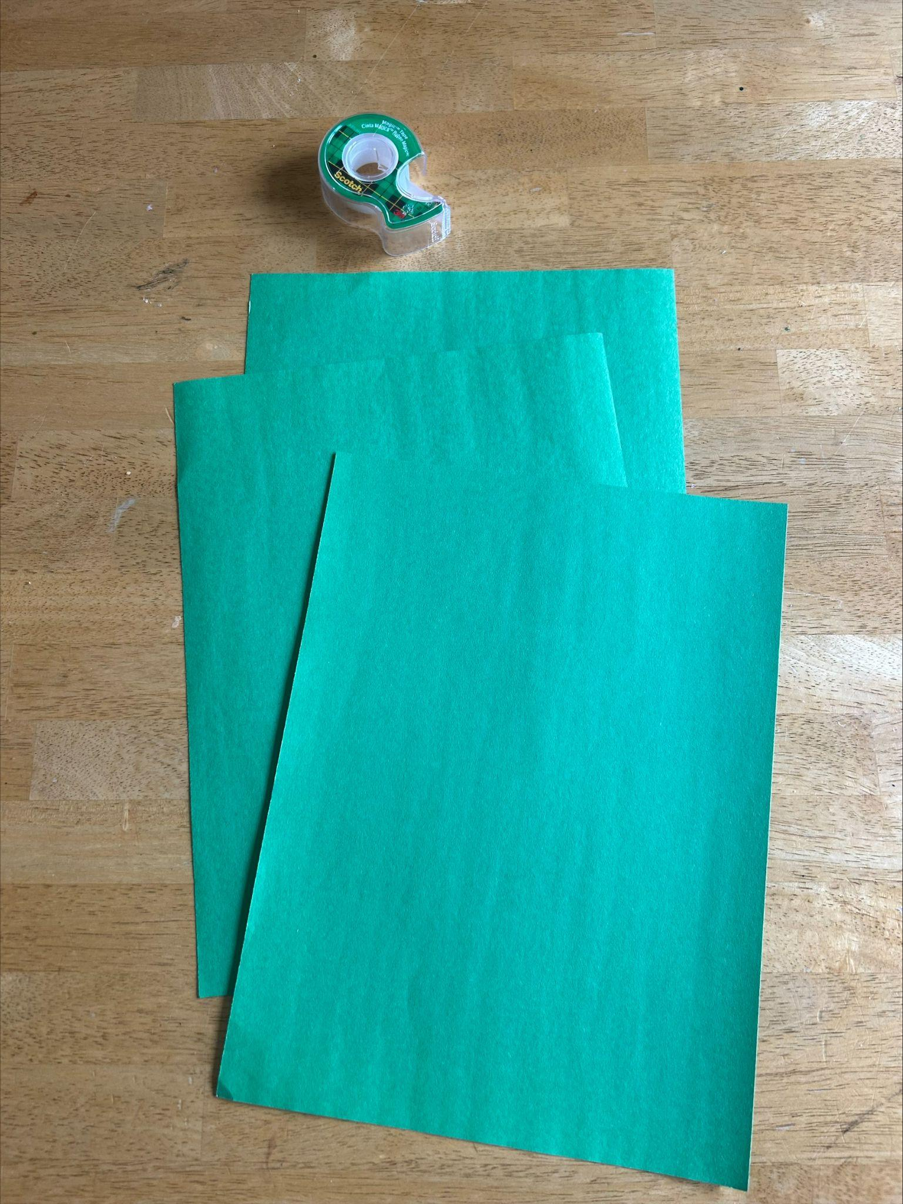 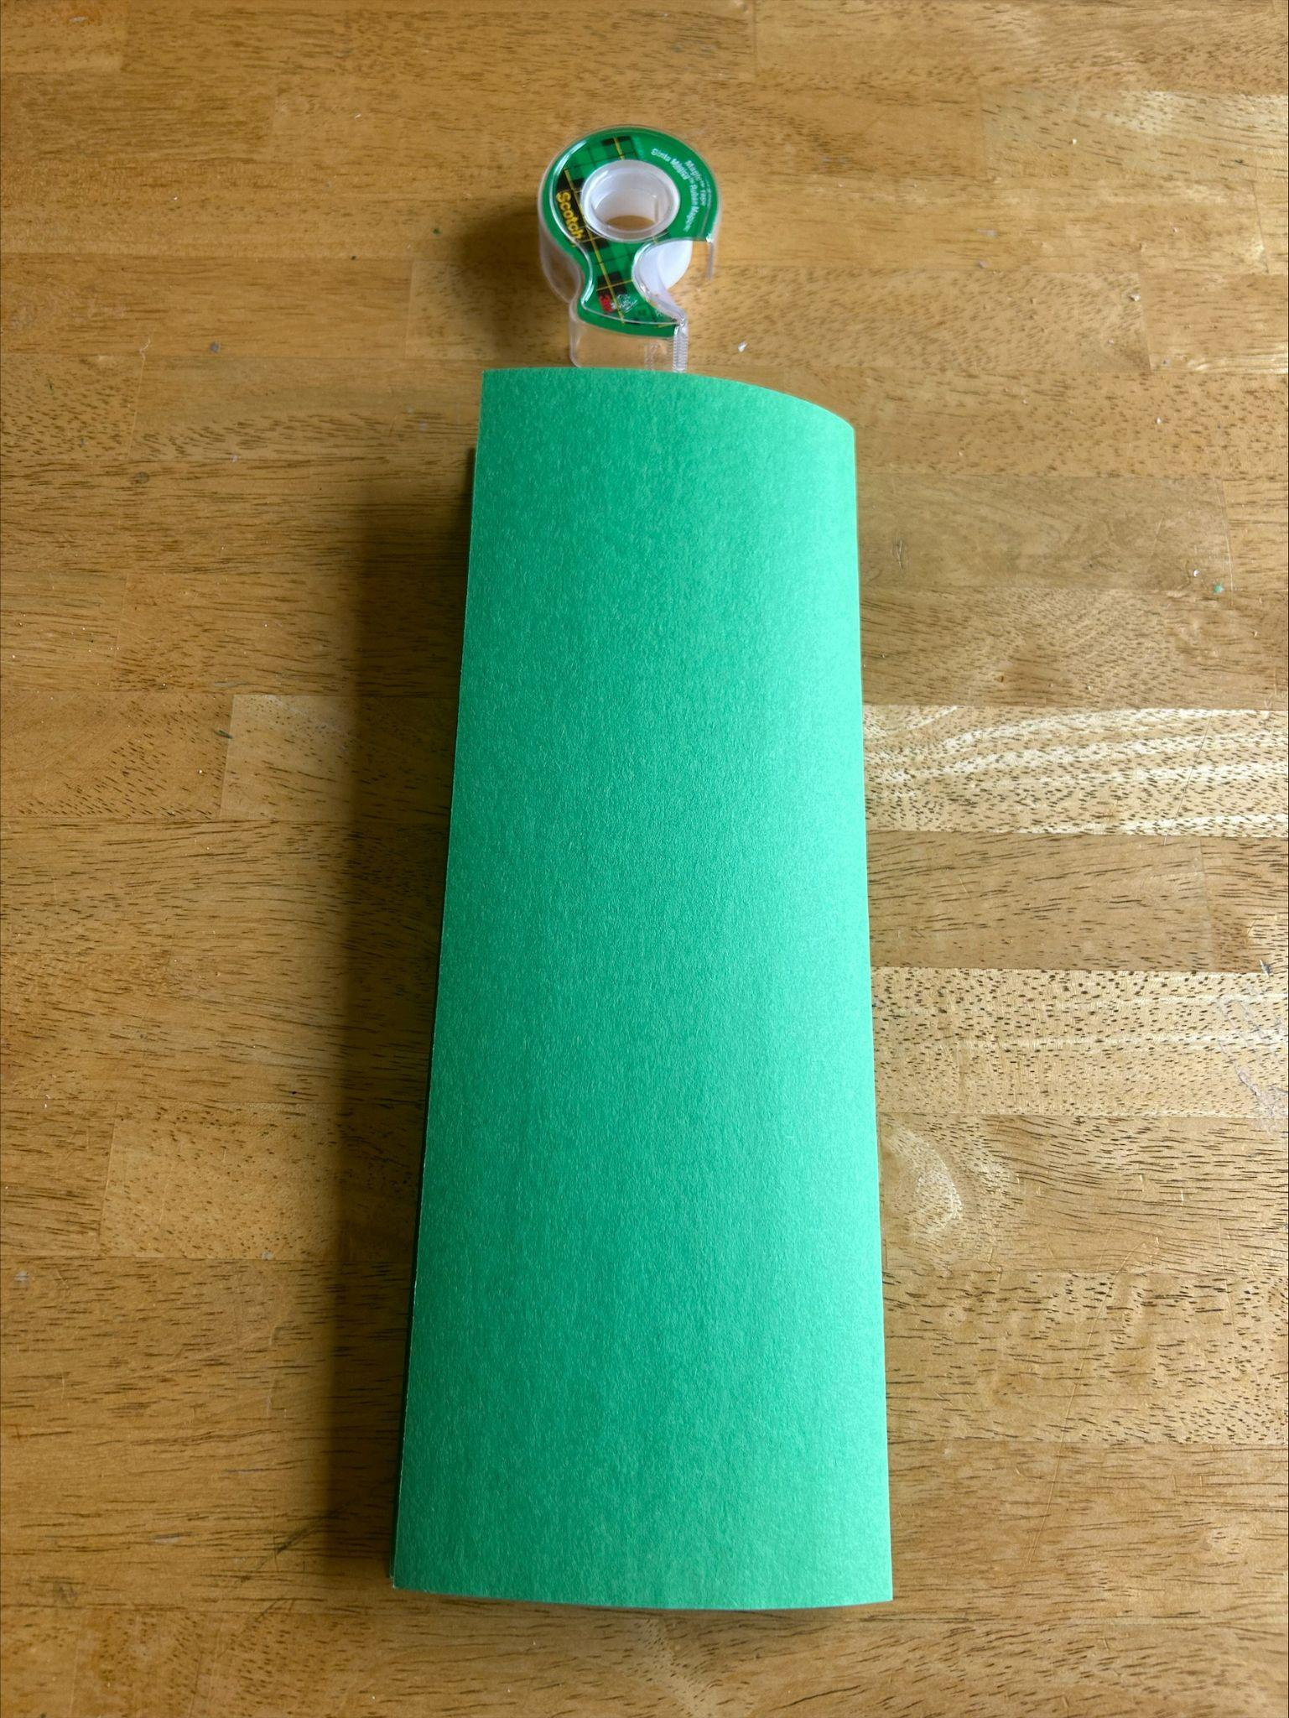 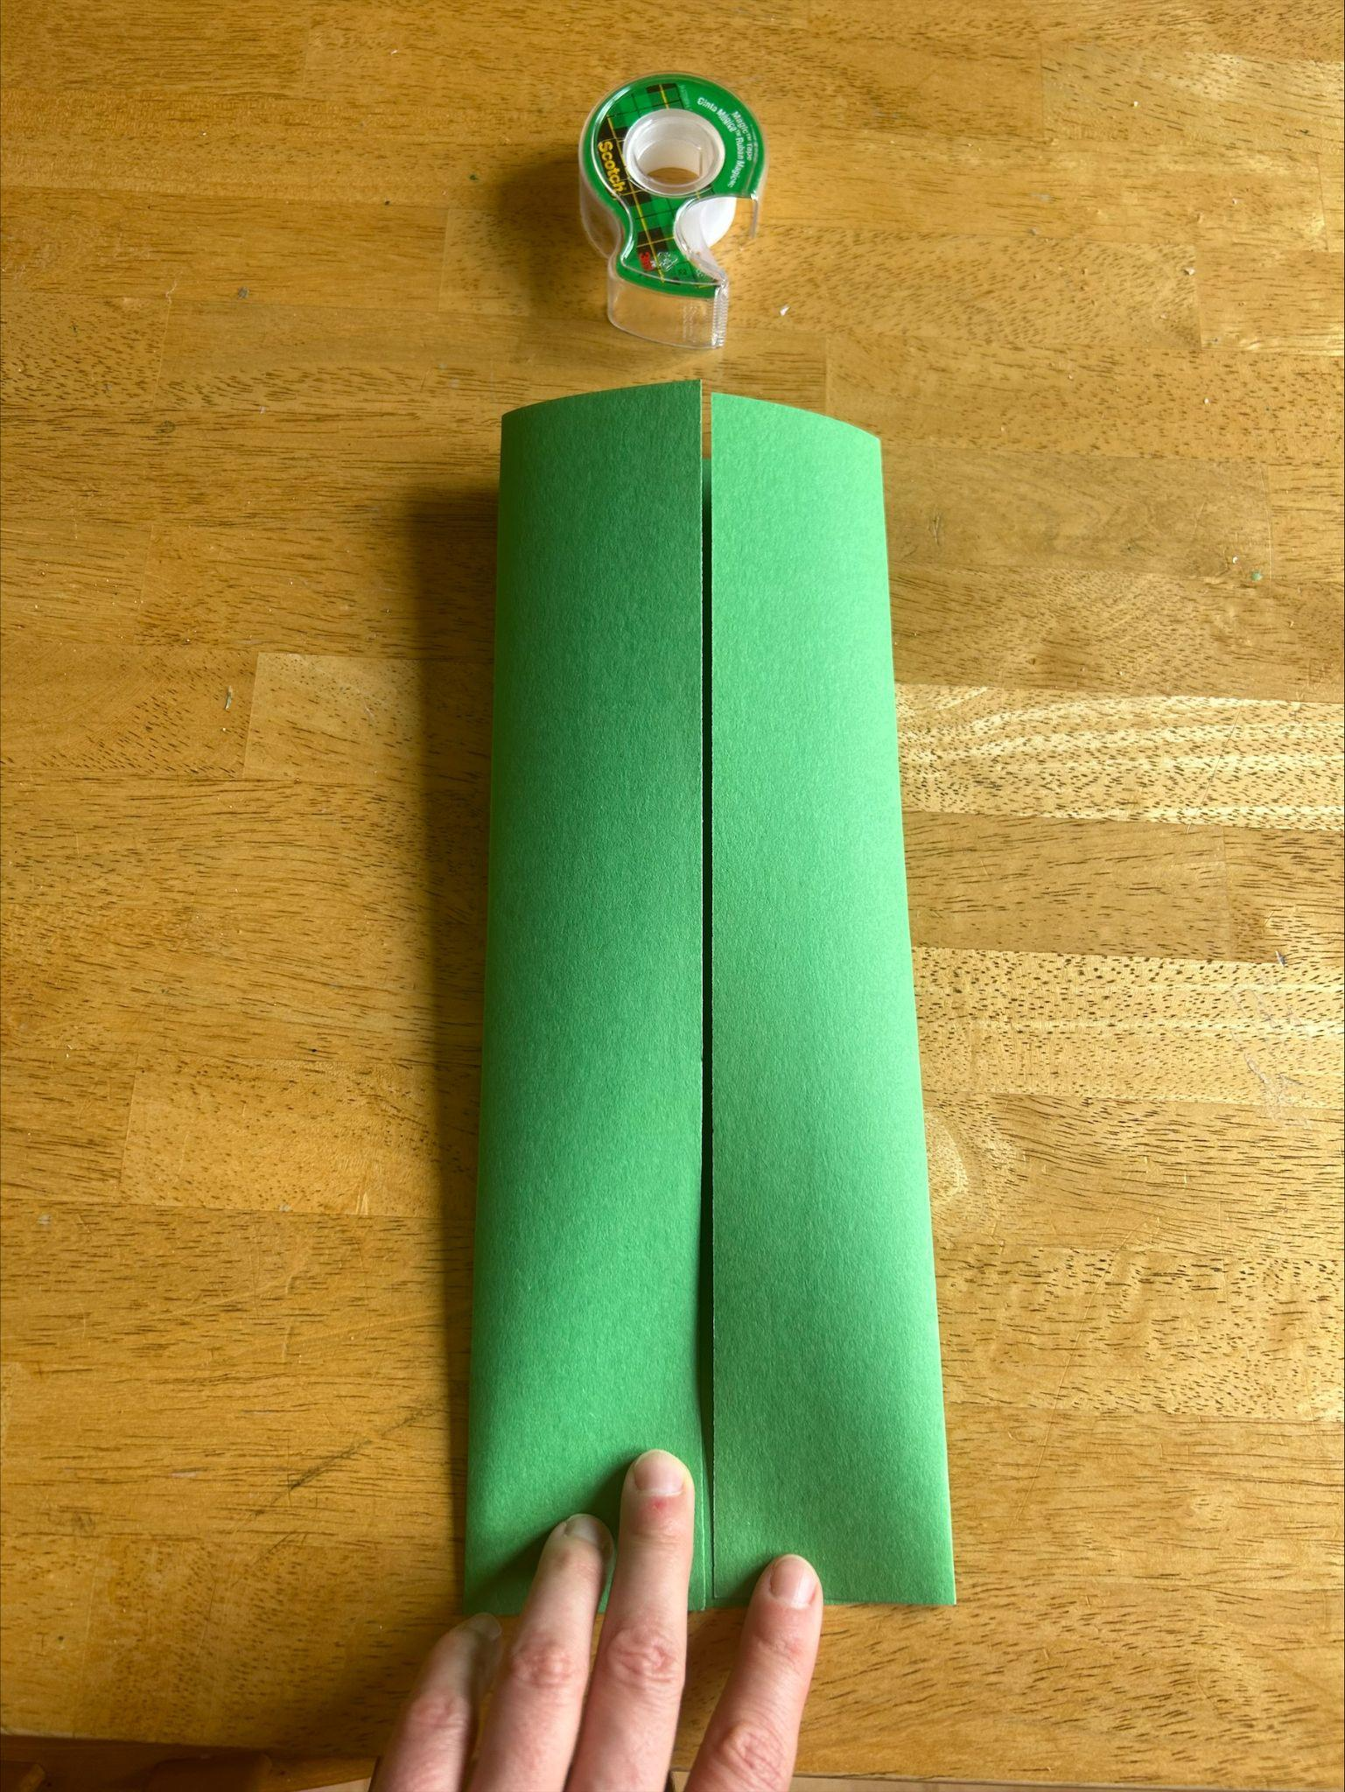 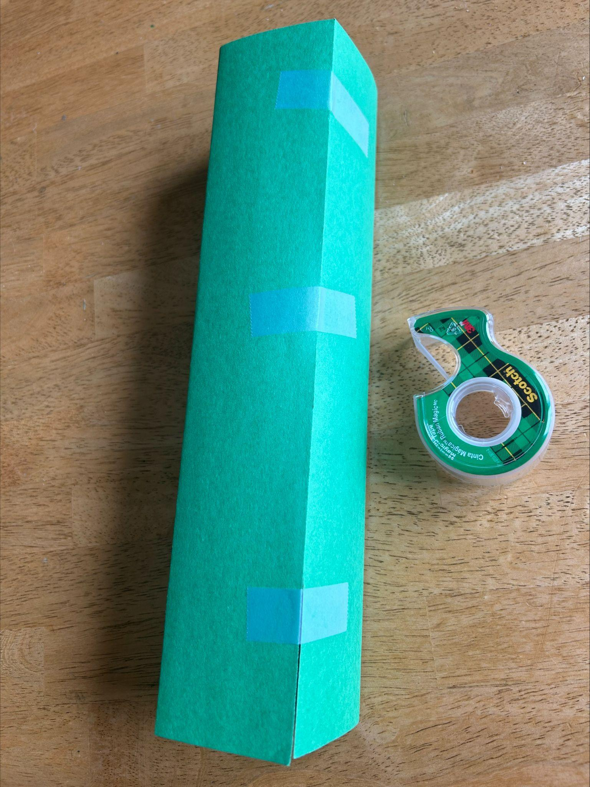

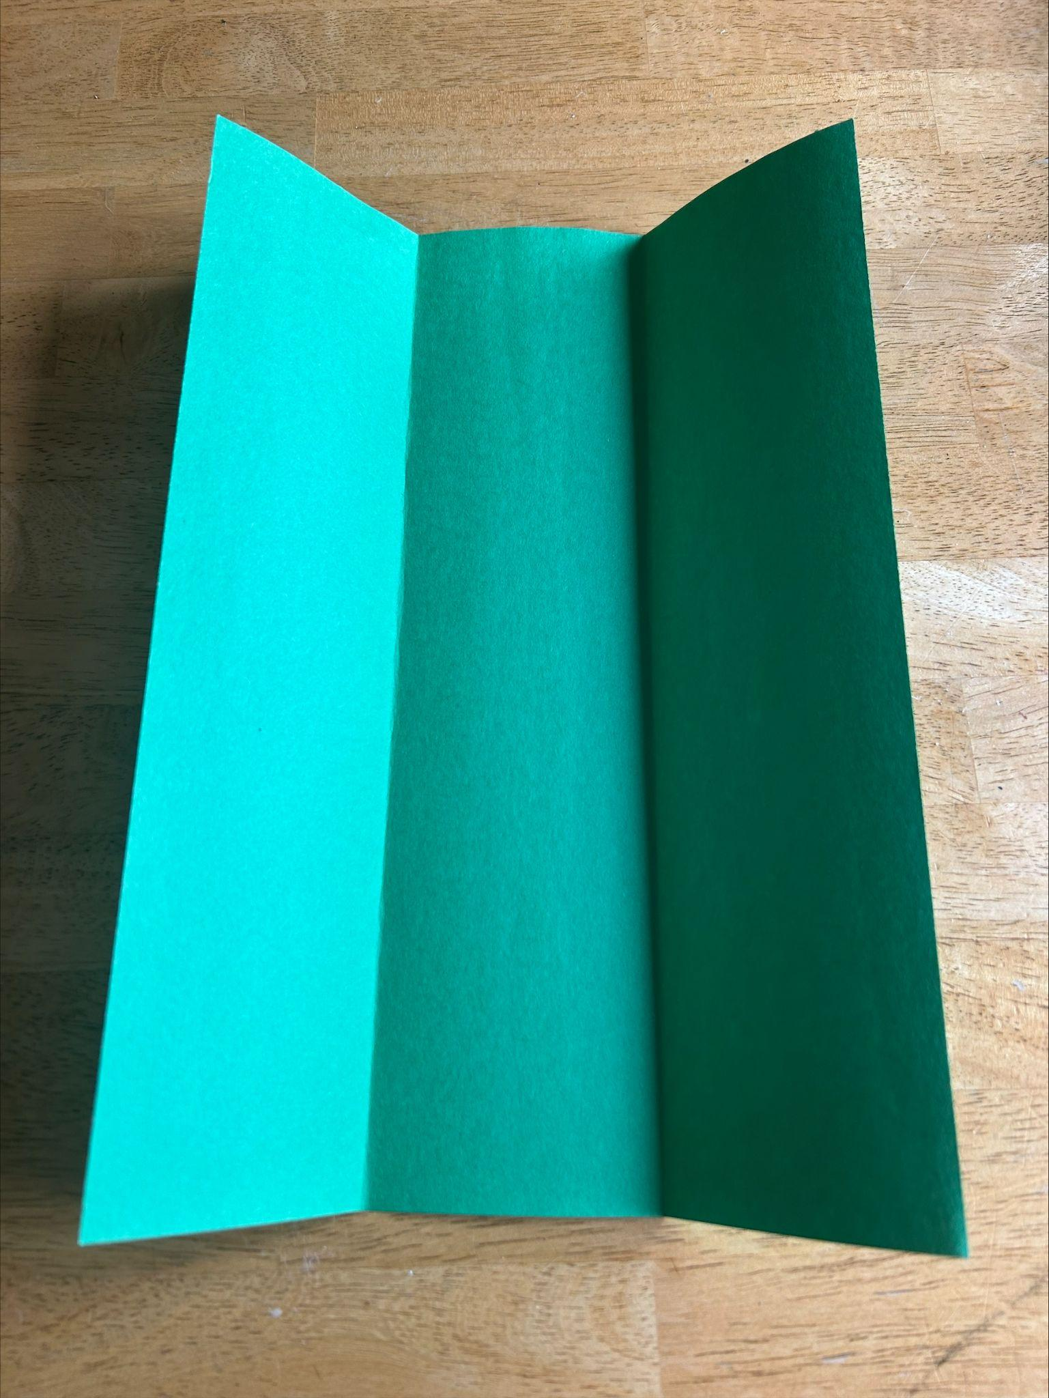 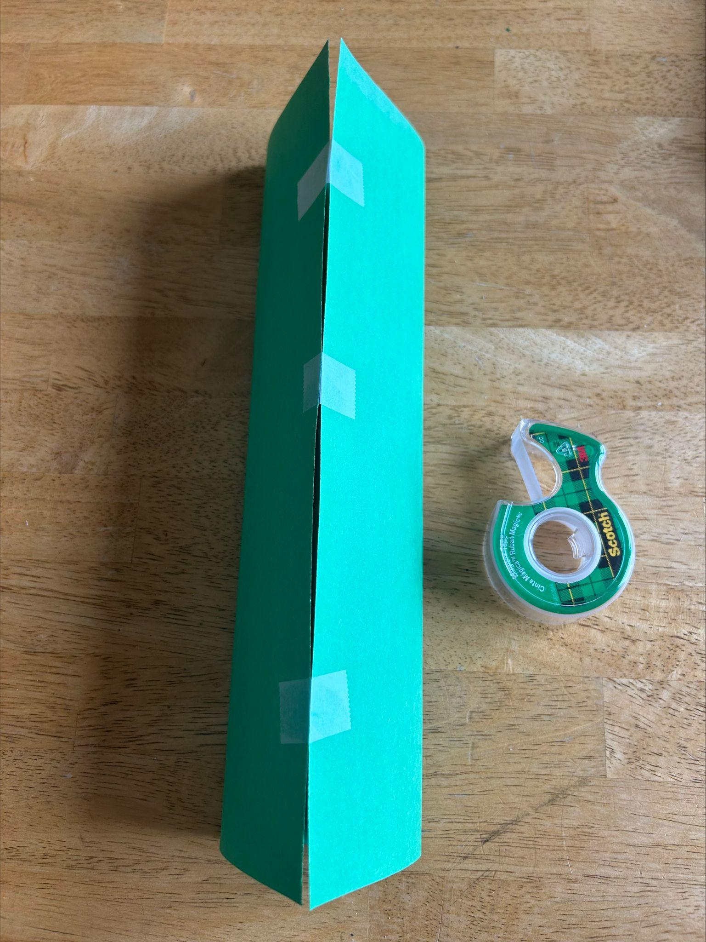 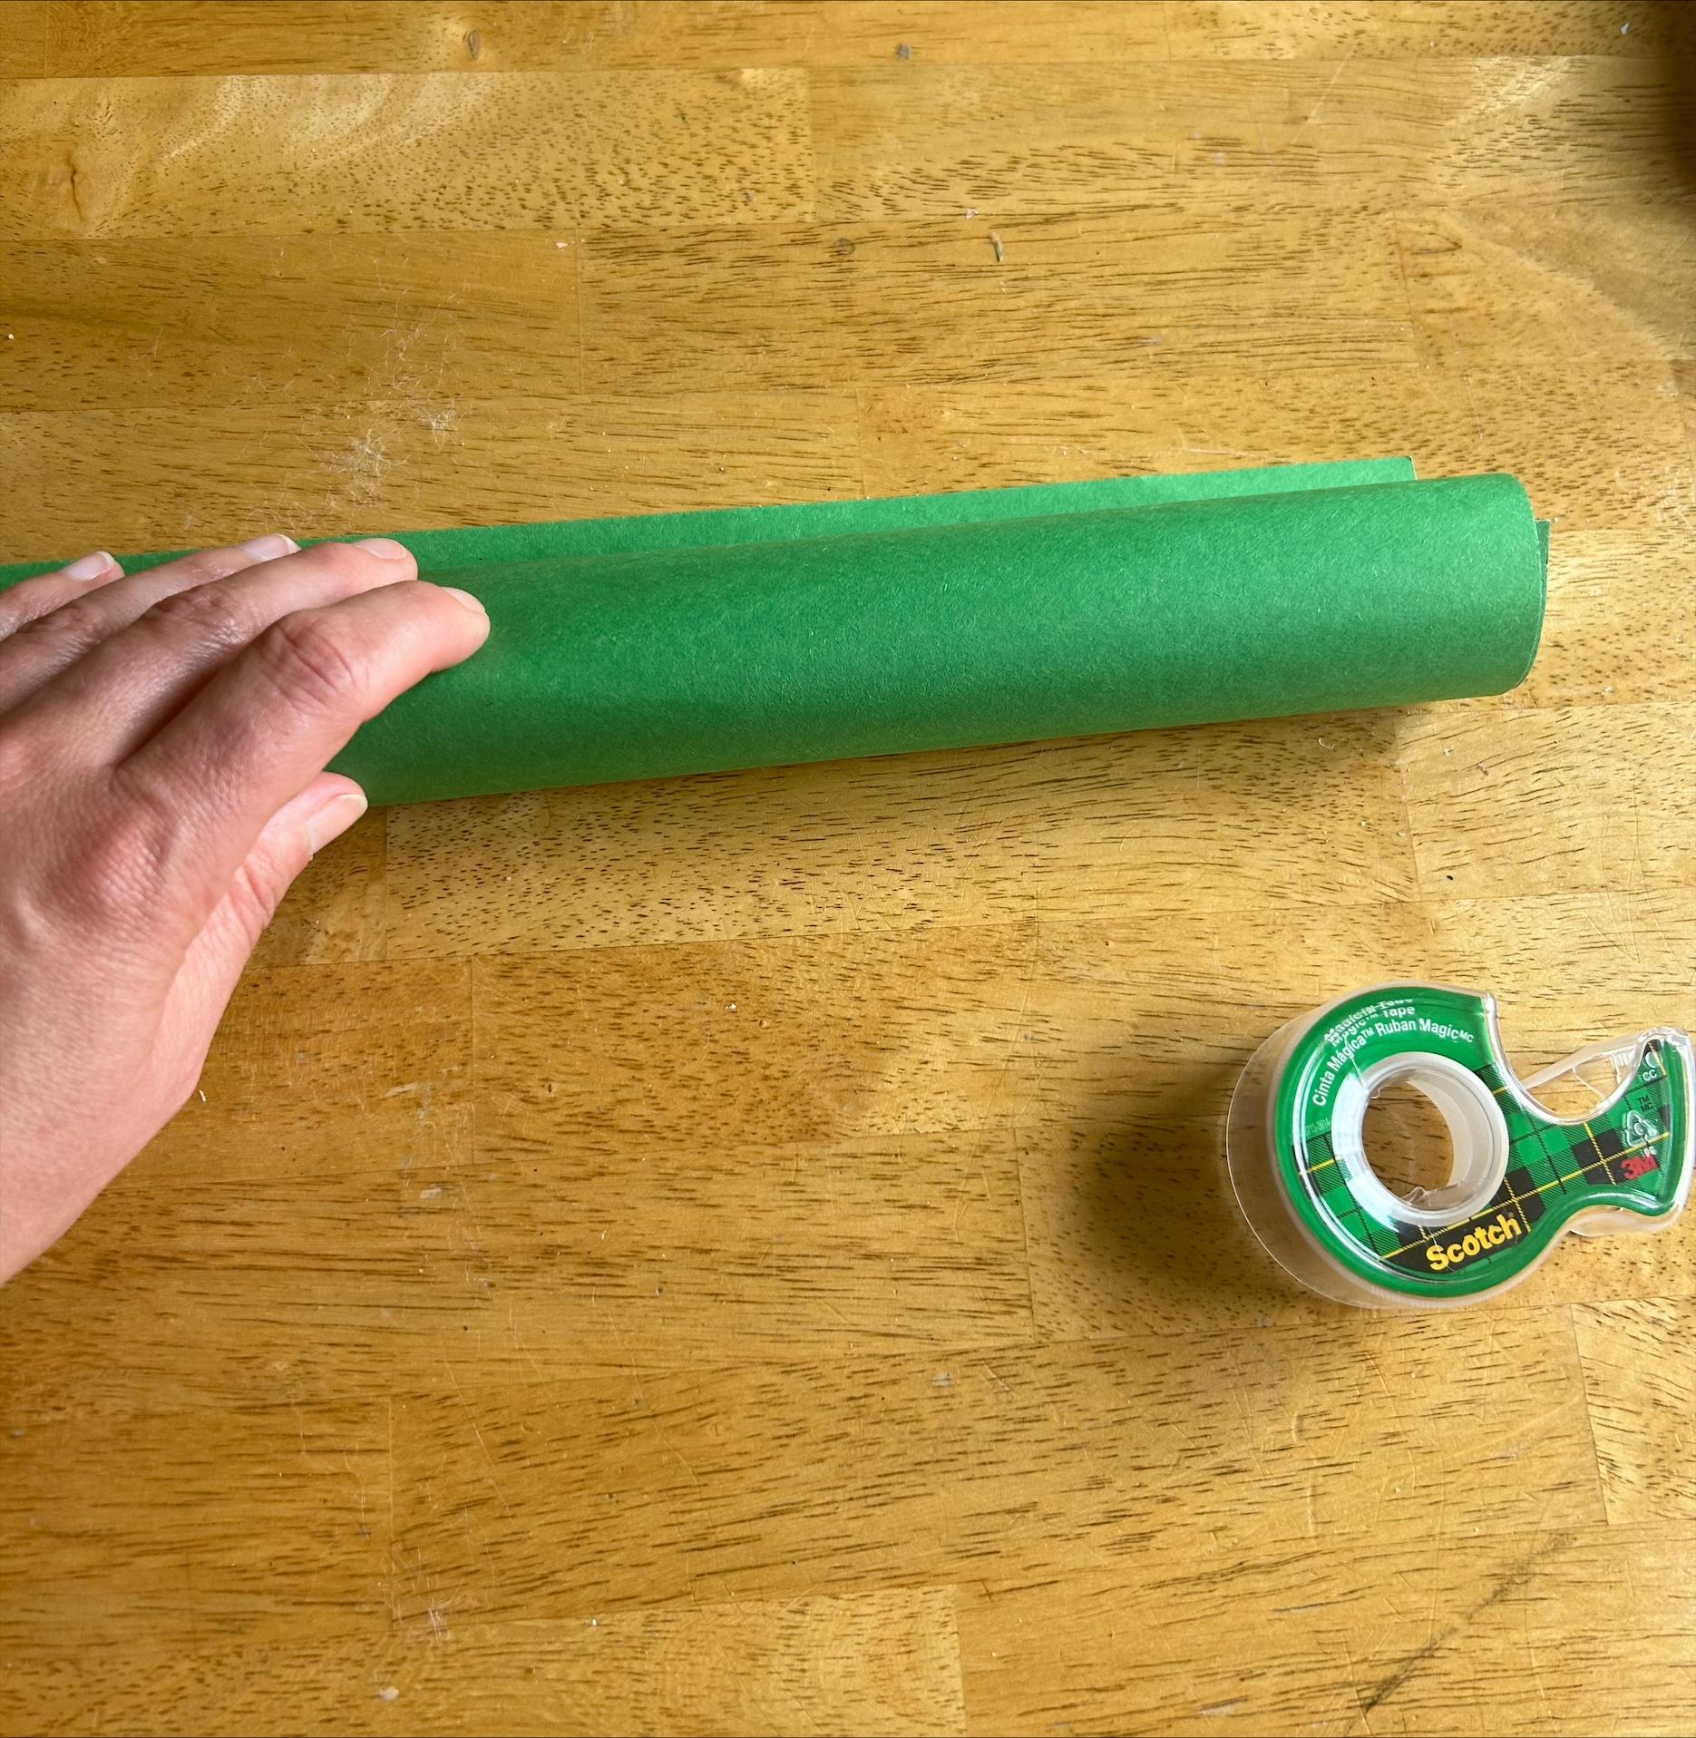 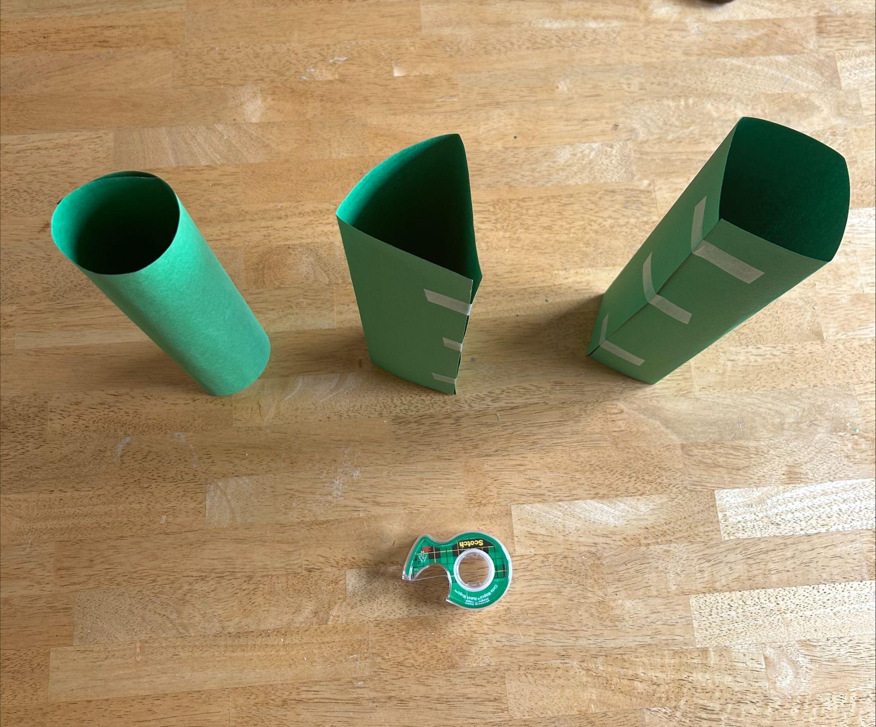

1. **Testing**

* Gradually add weights to paper shape
* Record how much each shape can hold before collapsing (2 books, or 3 books ect…)
* Use same weight for each shape for consistency (in the classroom could be the students journals, or library books)

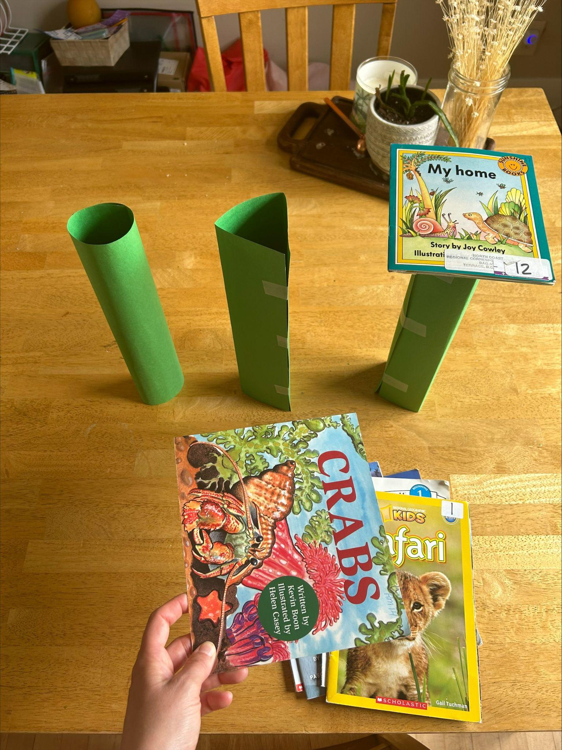 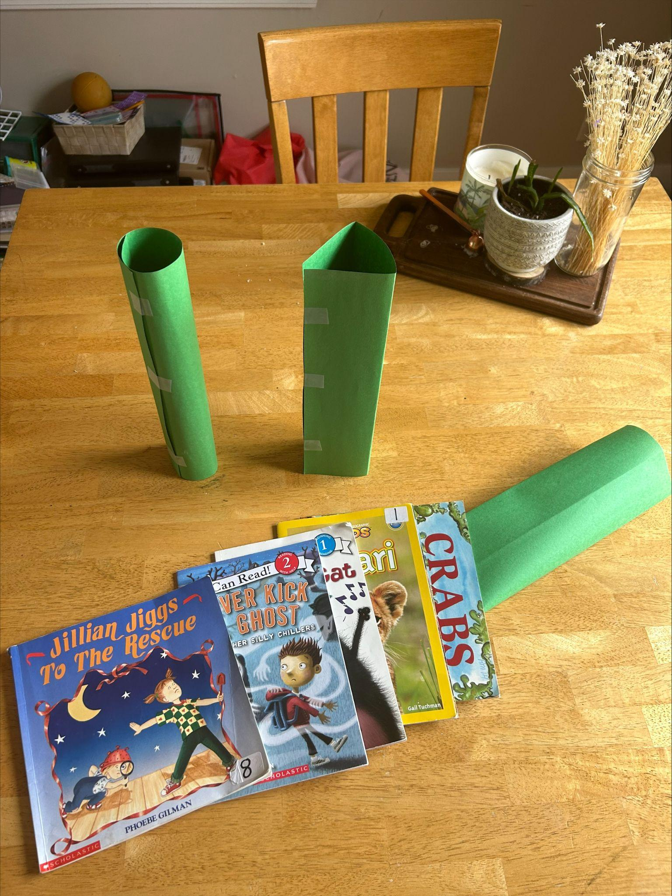 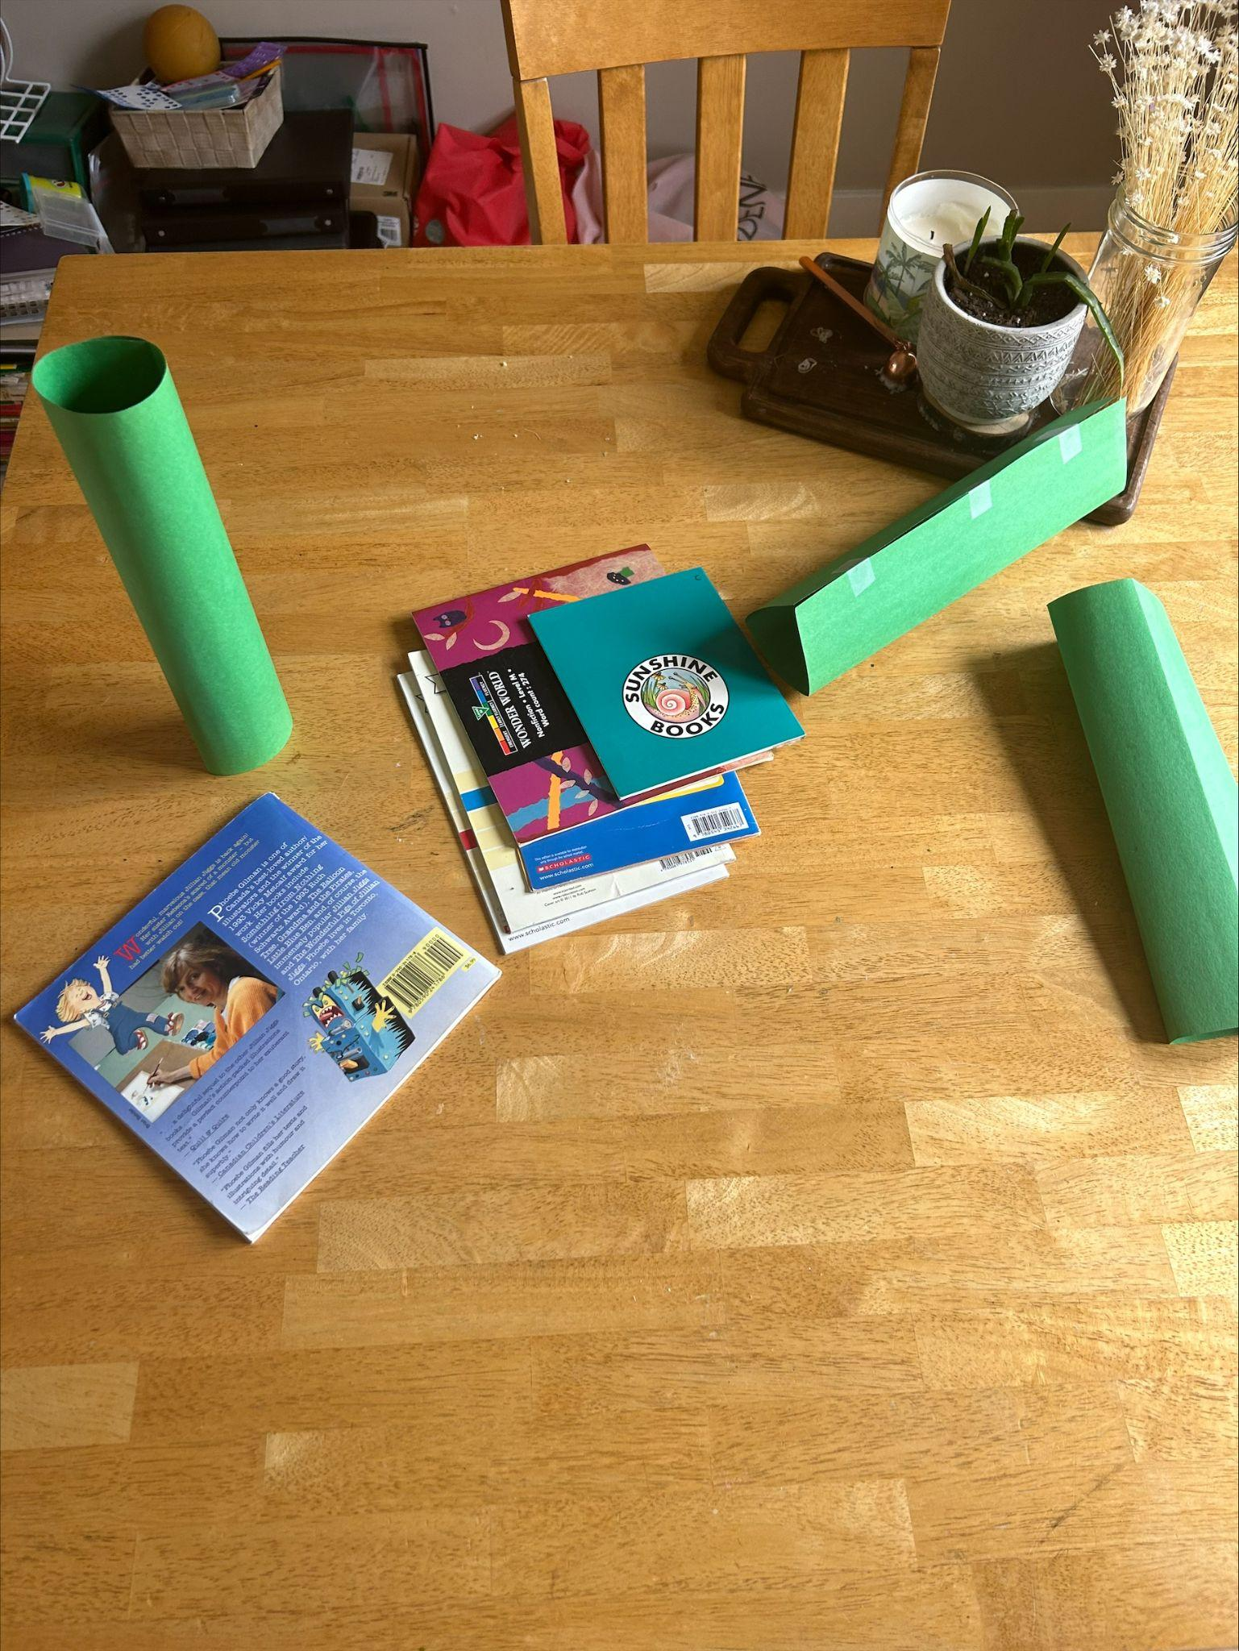 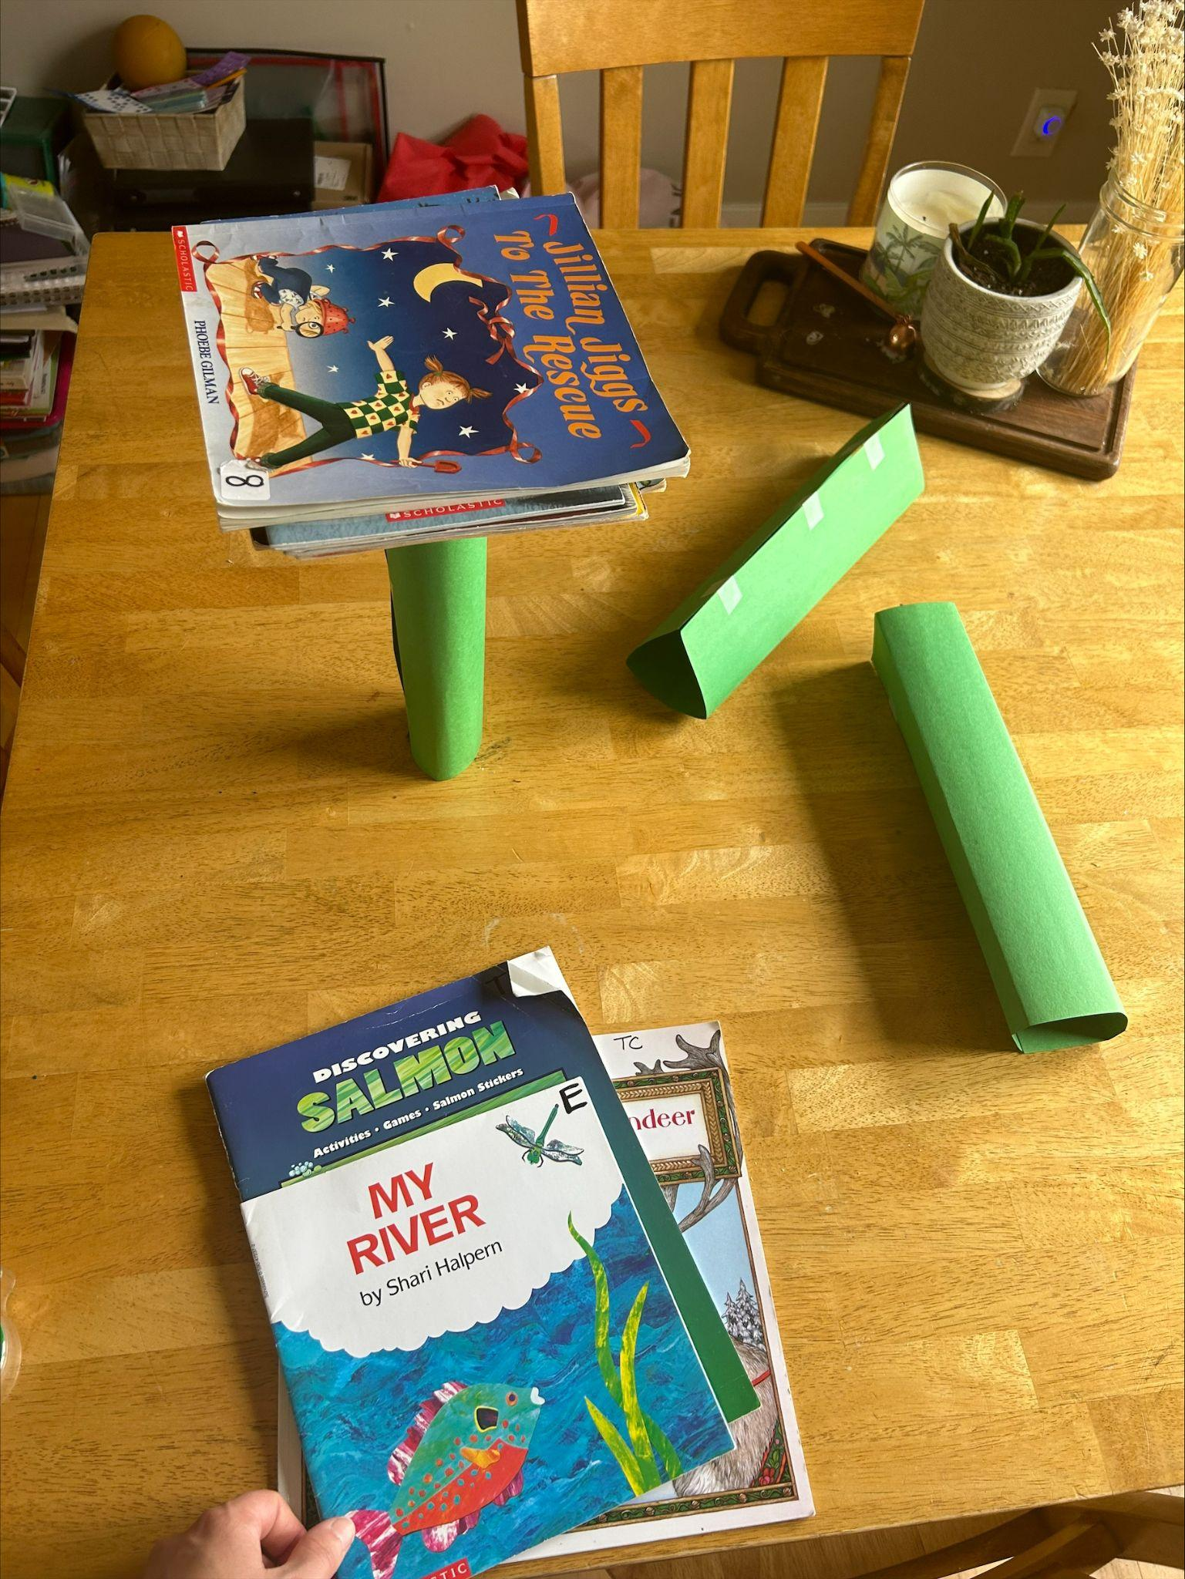

1. **Analyze**

* Compare the results of the different shapes
* Record results on a class graph or chart

1. **Conclusion**

* Have students present their findings
* Discuss any surprises and what they learned about shapes and strength

**Extension Ideas**

* Repeat activity with different types of paper to see how material affects strength
* Could try creating more complex structures using combinations of shapes to see if they can withstand more weight
* Could calculate the surface area and volume of the shapes
* Could try giving no information on how to construct the shapes to see what students build on their own